PHINMA MESSAGE BOARD (WEB)
Project by: Group 1/BSIT2-05
Overview by: Aldrich C. Navarro(Group 1/BSIT2-05)

Members:
- Colorada, Wrench
- Maranion, Rea Regie
- Miraflores, Julie Ann
- Monje, Theo Jibrael
- Navarro, Aldrich
- Padilla, Steven

Phinma Message Board(WEB)
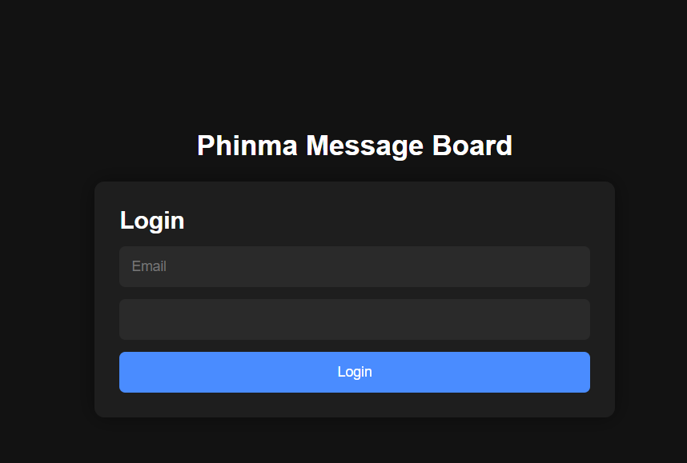

Phinma Message Board(Web) is the main console of the Phinma Message Board(App) with its main point of usage being:
- To handle users
- To manage Boards
- To manage Threads
- To manage Messages
While also having the regular functions of the application. This is mainly intended for the Admin to have ease of access in modifying the contents of Phinma Message Board.

HOME SCREEN
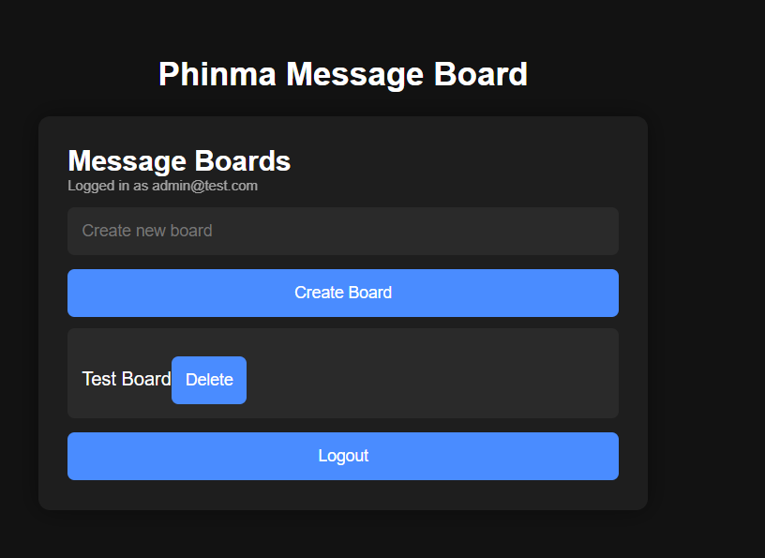
This is the home screen of Phinma Message Board(Web) viewed in the perspective of an Admin Account. An admin can manage resources that users cannot.

Such as this Admin button that leads you to the firebase console.
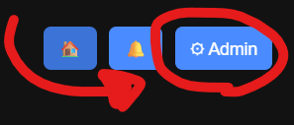
Other functions are the same as the application.

Known Issues
- Notifications appear during login screen.
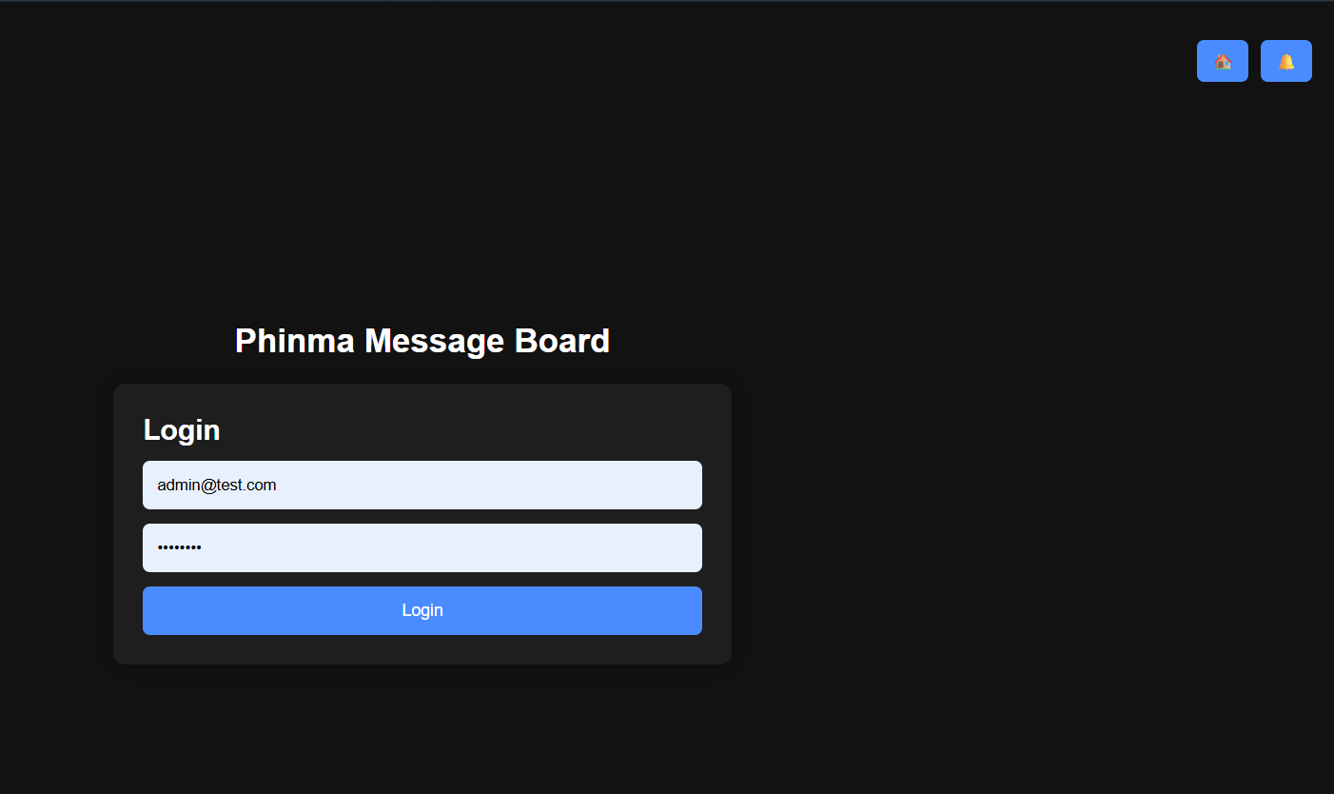

- Admin console button appears when you logged out from an admin account.
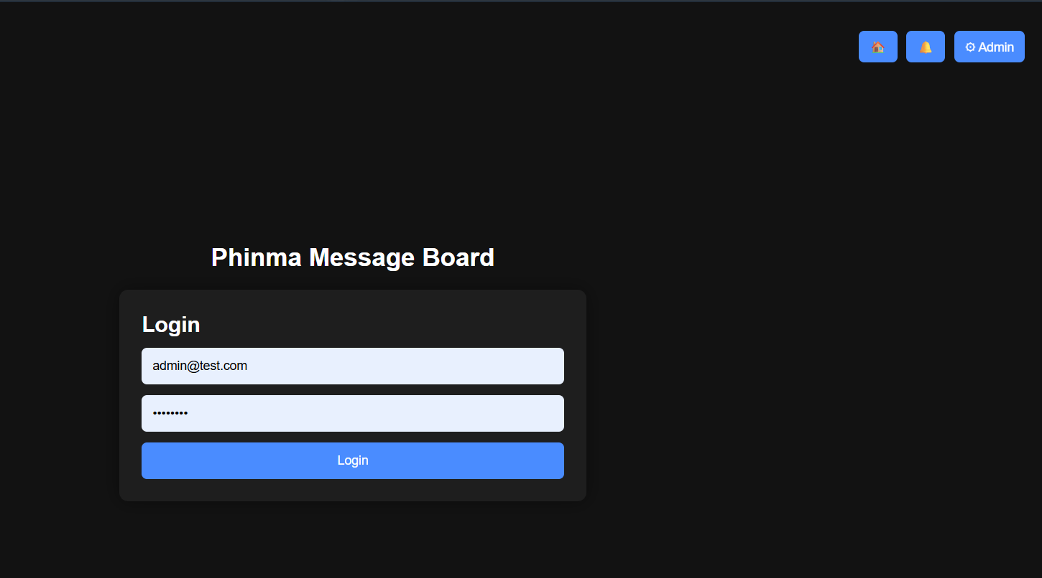

- Clicking Home button logs in the last user instead.
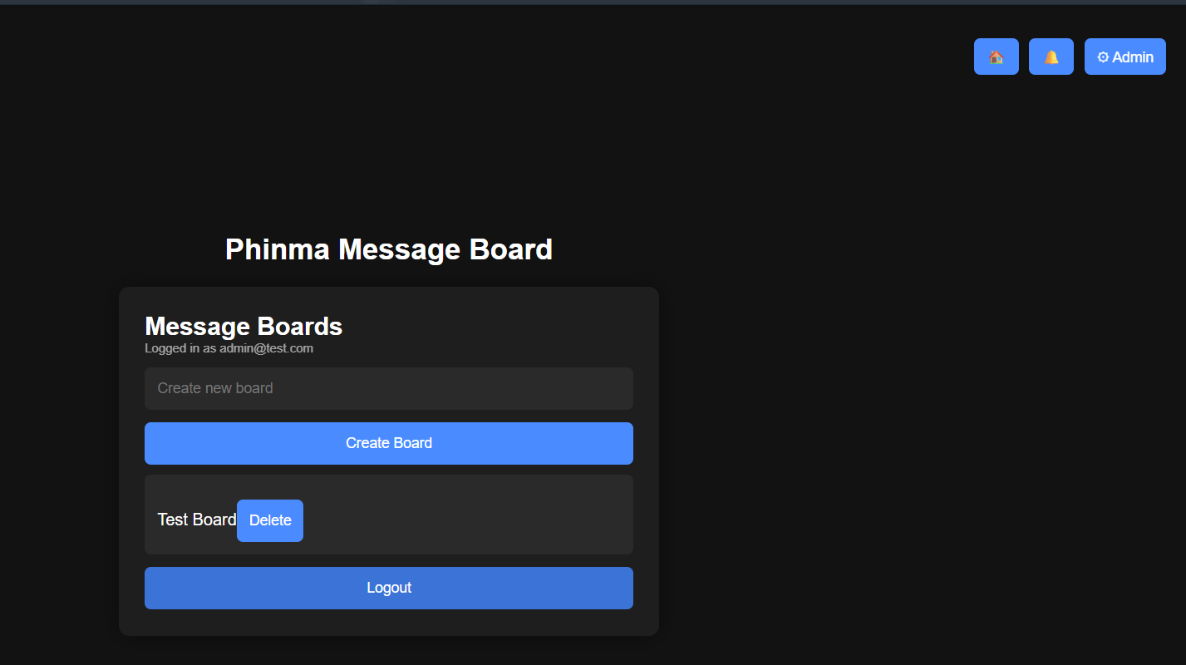
You are also forced to not logout.
This will all be fixed in the next checking… hopefully…

Planned Implementations:
- Web
- Full Scale Administrator Dashboard
- User management function in-web (If possible)
- Web and App
- Real notification system
- Thread bookmarking
- Many more(?)

That’s all, thank you!

